**DETECTION OF FAKE NEWS ON SOCIAL MEDIA NEWS WEBSITES USING MACHINE LEARNING ALGORITHMS**

**BY**

**AFOLABI MERCIFUL ADEOGO**

**MATRIC NO: 17/52HL017**

**A PROJECT SUBMITTED IN PARTIAL FULFILMENT OF THE REQUIREMENTS FOR THE AWARD OF BACHELOR OF SCIENCE DEGREE IN INFORMATION AND COMMUNICATION SCIENCE**

**JANUARY, 2022**

**CERTIFICATION**

This is to certify that this project work was carried out by Afolabi Merciful Adeogo with matriculation number 17/52HL017 in the department of Information and Communication Science, University of Ilorin, Ilorin Nigeria

Mrs Shakirat O. Haroon Sulyman _______________________

Supervisor Signature & Date

Dr. A.M Adeshina ______________________

Head of Department Signature & Date

**DEDICATION**

This project is dedicated to God who has been my help and source of inspiration all through the research.

And to my parents, siblings, friends for the care and support showed to me all time.

**ACKNOWLEDGEMENT**

I am grateful to my research supervisor, Mrs Shakirat O. Haroon Sulyman for her advice, support, suggestions, encouragement, constructive criticism and forgiving heart throughout this project.

My sincere appreciation goes to my parents, siblings and friends for their support. Finally, to God for His continuous grace and protection.

**ABSTRACT**

Fake news refers to intentionally and verifiably false stories that are largely disseminated through social media networks or the internet. Such news can be very persuasive, which makes it necessary to develop strategies to identify and critically assess news read and circulated on social media. In view of this, this study presents a system to detect fake news on social media websites using supervised machine learning algorithms. Previous efforts in defining and automating the detection process of “fake news” were also reviewed. In this study a real world dataset gotten from an online repository was used in feeding and training the machine learning algorithms. This dataset was pre-processed and extracted using feature extraction. Three supervised machine learning algorithms were used in training and testing the model. The three algorithms were Random Forest Classifier, Logistic Regression Classifier, and Support Vector Classifier. The system performance was determined by accuracy, precision, recall, f1-score, sensitivity and specificity rate. Results gotten shows that these system performs excellently in detection fake news.

**TABLE OF CONTENTS**

CHAPTER ONE 1

INTRODUCTION 1

1.1 Background of the study 1

1.2 Statement of the Problem 3

1.3 Objective of the Study 4

1.4 Significance of the Study 4

1.5 Scope of The Study 5

1.6 Limitation of the Study 6

1.7 Operational Definition of Terms 6

CHAPTER TWO 8

Literature Review 8

2.2 Introduction 8

2.2 Concept of Fake News 9

2.2.1 Fake News on Social Media 10

2.2.2 Machine Learning 16

2.2 Fake News Detection on Social Media 24

CHAPTER THREE 29

3.1 Introduction 29

3.2 Research Design 29

3.3 Research Tools and Materials 29

3.4 Dataset 30

3.5 Method of Data Collection 30

3.6 Training and Testing 32

CHAPTER FOUR 35

4.1 Introduction 35

4.2 Descriptive Analysis of Dataset 35

4.2.1 Count Plot of Dataset 39

4.2.2 Check For Null Values In The Dataset 40

4.2.3 Training and Testing Data 41

4.3 Experimental Result Analysis and Comparisons of Algorithms 41

4.3.1 Result Analysis 42

4.3.2 Comparisons of Algorithms 48

CHAPTER FIVE 52

5.1 INTRODUCTION 52

5.2 SUMMARY 52

5.3 CONCLUSION 53

5.4 RECOMMENDATION 54

REFERENCES 55

**LIST OF FIGURES**

Fig 2.1: Pictorial example of a clickbait on social media………….……………11

Fig 2.2: Pictorial example of a propaganda story on social media……………...12

Fig 2.3: Pictorial example of a satire/parody post on social media……………..12

Fig 2.4: Pictorial example of sloppy journalism news…………………………..13

Fig 2.5: Pictorial example of misleading headline news on social media………14

Fig 2.6: Pictorial example of a slanted news on social media…………………..15

Fig 2.7: Supervised machine learning classifying shapes……………………….19

Fig 2.8: Unsupervised machine learning classifying dog and cat……………….20

Fig 2.9: Semi-supervised machine learning to classify the unlabeled apple……21

Fig 2.10: Reinforcement machine learning process diagram……………………22

Fig 2.11: Transfer machine learning process diagram…………………………..24

Fig 4.1: Original fake news dataset downloaded from kaggle.com……………..36

Fig 4.2: Original real news dataset downloaded from kaggle.com……………..36

Fig 4.3: News dataset after dropping unneeded columns………………………..37

Fig 4.4: Histogram of real and fake news…………………………......................38

Fig 4.5: News dataset after preprocessing……………………………................38

Fig 4.6: Count plot of dataset…………………………………………………...39

Fig 4.7: Null values in dataset………………………………………………….40

Fig 4.8: Confusion matrix of random forest classifier……………….................42

Fig 4.9: Confusion matrix of logistic regression classifier……………………..42

Fig 4.10: Confusion matrix of Support vector machine…………………………43

Fig 4.11: Confusion matrix result of Random forest in percentage….................48

Fig 4.12: Confusion matrix result of Logistic regression in percentage………...48

Fig 4.13: Confusion matrix result of Support Vector Machine in percentage…..49

Fig 4.14: Manual entry input space for model testing…………………………..50

Fig 4.15: Manual entry news data and model prediction result……………..….51

CHAPTER ONE

INTRODUCTION

* 1. **Background to the study**

There was once a time when every individuals interested in reading the news would have to sit back and wait till the following day before getting access to the latest news around the world or whichever field of news interested in, as the main means of passing news was solely newspapers. However, with the growth of internet and rapid adoption of social media platforms, dissemination of news became easier, more convenient and quick to access than it has ever been in history of man which paved way for different online news outlet, news portals and social media platforms as means of news dissemination with the likes of Facebook, Twitter, etc. gaining much popularity as a better alternative for consumers to access the latest news at their fingertips compared to the previous delay in accessing news of the next-day newspaper.

Over the recent years, the growth of online social media has greatly facilitated the way people communicate with each other. Users of online social media share information connect with other people and stay informed about trending events (Zhang & Ghorbani, 2020). With the advent of online news portals and social media platforms, this has resulted in the creation of a powerful tool to share and spread fake news and false stories extensively. Fake news refers to the online publication of intentionally or knowingly false statement of facts (Klein & Wueller, 2017). Fake News has been defined in many terms, another agreed term of definition is: It’s atype of yellow journalism or propaganda that consists of deliberate misinformation or hoaxes mostly spread via broadcast news media or online social media. The internet has provided a low-cost distribution channel for fake news. Posting fake news in discussion forums, website comment fields, blogs and social media websites requires little, if any, technical know-how. Social media websites in particular have proved to be an easy venue for distributing fake news. The increasing openness, access and prevalence of the Internet resulted in its growth. New information and stories are published constantly and at a faster rate than ever, often lacking in verification, which may be consumed by anyone with an Internet connection --False stories can be tweeted or posted from a mobile smartphone or personal computers and quickly distributed to a large audience through retweets and sharing. This makes the problem of fake news very difficult to address and combat in technological we live in now. Fake news are usually made to be very enticing and can quickly spread when it provides disinformation that is aligned with the audience's point of view because such content is not likely to be questioned or discounted, which is why the essence for a fake news detection is so inevitable and this study would be using a subset of artificial intelligence (AI) in detecting and resolving it. Machine learning as technology helps analyse large chunks of data, easing the tasks of data scientists in an automated process and is gaining a lot of prominence and recognition.

* 1. **Statement of the Problem**

Despite the undeniable importance of social media platform and social media networking as a whole, the proliferation of Fake News on social media has been a source of widespread concern. False information dressed as news has created serious concerns in many countries. Some researchers have called it information pollution (Wardle & Hossein, 2017), media manipulation (Warwick & Lewis, 2017), or information warfare (Khaldarova & Pantti, 2016), especially most common during natural disasters or crises, users on social media tend to easily believe contents of postings related to the events, and retweet the postings with the hope of them reaching to many other users. Unfortunately, there are malicious users who understand the tendency and post misinformation such as spam and fake messages with expectation of wider propagation.

This study aims to provide a technique for detecting online fake news using machine learning algorithms. Disinformation is a historic phenomenon which has been long before the social media era, as each new communication technology allows for new ways to manipulate and amplify disinformation to people and societies, given that, this study will explicitly help in identifying authenticity of the news posted online on news platforms, by predicting and differentiating fake from real news.

* 1. **Objective of the Study**

The aim of this study is to develop an effective fake news detection model to help counteract the burdensome challenge of fake news on social media using different supervised machine learning algorithms. Specifically, the objective of this study will be:

1. To evaluate the effectiveness and accuracy of machine learning in detecting the credibility of news.
2. To design and implement a system to detect and classify fake and real news.
3. To compare and evaluate the efficiency of the machine learning system with various previously existing systems implemented in detecting fake news
   1. **Significance of the Study**

Machine learning models learn, identify patterns, and make decisions with minimal intervention from humans. Ideally, machines increase accuracy and efficiency and remove (or greatly reduce) the possibility of human error. The machine learning field is continuously evolving, increasing it high demand and importance in our environment and everyday world, most especially in supervised binary classification which collect data or produce a data output from the previous experience and helps you to optimize performance criteria using experience, prioritising ‘High-value predictions which can guide better decisions and smart actions in real-time without human intervention’.

This research study will add to the global literature on supervised binary classification techniques of machine learning and it also highlights factors and features involved in the different machine learning techniques and algorithm to be utilized in detecting fake news in this study. This research study also will be relevant to students and individuals at large in sensitizing them about the wide study of machine learning, the background, the importance, the features, the limitations and general knowledge of supervised learning of machine learning which would foster more individuals to be interested and inclined into the knowledge, programming and manipulation of data to get desired result with minimal human intervention.

* 1. **Scope of The Study**

The scope of this study will cover news data from different social media websites with news data from 2017-2018, due to the availability of large range of data present in this period as this study aim to develop a machine learning system to help detect the fake news with the use of the aforementioned data in the system. All these will be covered within this study in order to fully encompass and effectively achieve the aim of the study.

* 1. **Limitation of the Study**

Despite all the significance and importance attached of this project, this is also likely to be affected some limitations, which include:

1. Gathering of exceptionally large amount of online data to be used through the system testing and training process could cumbersome.

2. Another issue would be twitter ban in place in country at the moment limiting access to data scraping, resulting in the use of kaggle data as an alternative.

* 1. **Operational Definition of Terms**
* **Social Media**: This is a form of electronic communication such as websites for social networking through which users can share information, messages, and other content.
* **Social Media News Websites:** Websites that enable users to create, share and read content or to participate in social networking, particularly relating to sharing of news.
* **Fake News:** Fake news refers to false reports or news shared in the form of articles, images, etc., which are disguised as “real news” and aim to manipulate people’s opinions
* **Artificial Intelligence (AI)**: This is a computer system able to perform tasks normally requiring human intelligence, such as classifying real from fake news.
* **Machine Learning (ML)**: This is a concept to be used in this study to feed the computer news data to learn from, in order to effectively classify the fake from real news without being explicitly programmed based on the data fed.
* **Dataset**: A dataset in is basically a collection of data collected to be made understandable for a machine that doesn't see data the same way as humans do.
* **Supervised Machine Learning**: It is a method of machine learning, defined by its use of labeled datasets to train algorithms to classify data or predict outcomes accurately.

CHAPTER TWO

Literature Review

* 1. **Introduction**

Fake news in our society is not a new challenge; it has always been a challenge. Before the era of digital technology, it was spread through mainly yellow journalism with focus on sensational news such as crime, gossip, disasters and satirical news (Stein-Smith, 2017). While fake news has circulated through media since the early days of mass communication, scholars and pundits have argued that recent years mark ‘the rise of the misinformation society’ (Pickard, 2016,). According to Wikipedia (2016), Politifact selected fake news as their Lie of the Year. There was so much of this in the 2016 United States election year, won by President Donald Trump that no single lie stood out, so the generic term was chosen.  Websites with fabricated content gained massive attention, such as the story that falsely claimed that the Pope endorsed the republican candidate Donald Trump (Ritchie, 2016). Fake news was also named the word of the year in 2017 by the Collins Dictionary. In 2017, the usage of the term had increased by 365% since 2016 (Collins Dictionary, 2017). But even though the term seems fairly new, the phenomena it covers are old. Manipulation, disinformation, falseness, rumours, conspiracy theories—actions and behaviours which are frequently associated with the term—have existed as long as humans have communicated (Kalsnes, 2018). The way we access news articles and how we generally consume information online has changed. Social media has become the main vehicle for accessing news. Recent studies show that Facebook is one of the preferred sources of access to news, especially for the younger generation (Newman, Kalogeropoulos, Nielsen & Fletcher, 2019). The easy access and exponential growth of the information available on social media networks has made it intricate to distinguish between false and true information, this study aims to not just examines that but propose a method to combat the challenge and as well bridge the gap between different previous researches and studies on fake news and it detection.

* 1. **Concept of Fake News**

Fake news is a term that has come to mean different things to different people. At its core, it can be referred to as those news stories that are false: the story itself is fabricated, with no verifiable facts, sources or quotes (Desai, Mooney, & Oehrli, 2021). Media scholar Nolan Higdon has defined fake news as "false or misleading content presented as news and communicated in formats spanning spoken, written, printed, electronic, and digital communication (Higdon, 2020). Sometimes these stories may be propaganda that is intentionally designed to mislead the reader, or may be designed as “clickbait” written for economic incentives (the writer profits on the number of people who click on the story). The universe of “fake news” is much larger than simply false news stories. Some stories may have a nugget of truth, but lack any contextualizing details. They may not include any verifiable facts or sources. Some stories may include basic verifiable facts, but are written using language that is deliberately inflammatory, leaves out pertinent details or only presents one viewpoint. "Fake news" exists within a larger ecosystem of mis- and disinformation (Desai et al. 2021).

* + 1. **Fake News on Social Media**

In recent years, fake news stories have proliferated via social media, in part because they are so easily and quickly shared online (Desai et al. 2021).The easy dissemination of information by way of sharing has added to exponential growth of its falsification. The credibility of social media networks is also at stake where the spreading of fake information is prevalent. Thus, it has become a research challenge to automatically check the information viz a viz its source, content and publisher for categorizing it as false or true.

The prevalence of fake news relates to the availability of mass media digital tools (Schade, 2019). Since anyone can publish articles via digital media platforms, online news articles include well researched pieces but also opinion-based arguments or simply false information (Burkhardt, 2017). There is no custodian of credibility standards for information on these platforms making the spread of fake news possible. To make things worse, it is by no means straightforward telling the difference between real news and semi-true or false news (Pérez-Rosas, Kleinberg, Lefevre, & Mihalcea, 2018). (Webwise, 2021) Acknowledges differing opinions when it comes to identifying types of false news and information and examines different types of fake news and information to be aware of online, which includes:

* **Clickbait**: These are stories that are deliberately fabricated to gain more website visitors and increase advertising revenue for websites. Clickbait stories use sensationalist headlines to grab attention and drive click-throughs to the publisher website, normally at the expense of truth or accuracy.



**Figure 2.1: Pictorial example of a clickbait on social media (Webwise, 2021)**

* **Propaganda**: Stories that are created to deliberately mislead audiences, promote a biased point of view or particular political cause or agenda.

**Figure 2.2: Pictorial example of a propaganda story on social media (Webwise, 2021)**

* **Satire/Parody**: Lots of websites and social media accounts publish fake news **stories** for entertainment and parody



**Figure 2.3: Pictorial example of a satire/parody post on social media (Webwise, 2021)**

* **Sloppy Journalism**: Sometimes reporters or journalists may publish a story with unreliable information or without checking all of the facts which can mislead audiences

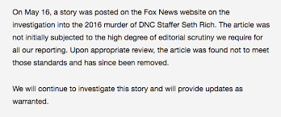

**Figure 2.4: Pictorial example of a sloppy journalism news being addressed after review (Webwise, 2021)**

* **Misleading Headings**: Stories that are not completely false can be distorted using misleading or sensationalist headlines. These types of news can spread quickly on social media sites where only headlines and small snippets of the full article are displayed on audience newsfeeds.

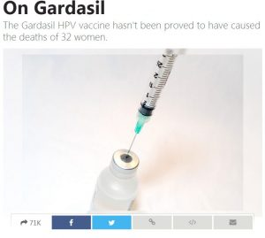

**Figure 2.5: Pictorial example of a misleading headline news on social media (Webwise, 2021).**

* **Biased/Slanted News**: Many people are drawn to news or stories that confirm their own beliefs or biases and fake news can prey on these biases. Social media news feeds tend to display news and articles that they think we will like based on our personalised searches.



**Figure 2.6: Pictorial example of a slanted news on social media (Webwise, 2021).**

This various types of fake news and information online elaborate how challenging it is to fully combat the problem of fake news rapidly prevailing in the social media world. In a recent article on media literacy, Hugh Linehan noted; “Media is no longer passively consumed – it’s created, shared, liked, commented on, attacked and defended in all sorts of different ways by hundreds of millions of people. And the algorithms used by the most powerful tech companies – Google and Facebook in particular – are brilliantly designed to personalise and tailor these services to each user’s profile.” When we go online or login to a social media network we are generally presented with news, articles and content based on our own searches online. This type of content tends to reflect our own likes, views and beliefs and therefore isolating us from differing views and opinions. This is often referred to as a filter bubble.

* + 1. **Machine Learning**

Machine Learning is the core subarea of artificial intelligence. Machine learning (ML) has been studied and defined by many researchers and scholars, all laying down their different definition to the term. (Ed Burns, 2021) defined Machine Learning as a type of artificial intelligence (AI) that allows software applications to become more accurate at predicting outcomes without being explicitly programmed to do so. (Gulli & Pal, 2017) also went ahead to define it in their book *Deep Learning with Keras* as a subset of the larger field of artificial intelligence (AI) that “focuses on teaching computers how to learn without the need to be programmed for specific tasks. They all point to similar direction as each definition explicitly explain it in simple terms, but a robust and elaborative definition is the definition by (Faggella, 2020) which states “Machine Learning is the science of getting computers to learn and act like humans do, and improve their learning over time in autonomous fashion, by feeding them data and information in the form of observations and real-world interactions.” The definition encapsulates the basic concept or ultimate aim of machine learning, as expressed by many scholars and researchers in the field.

Machine learning algorithms use historical data as input to predict new output values (Burns, 2021). The process of learning begins with observations or data, such as examples, direct experience, or instruction, in order to look for patterns in data and make better decisions in the future based on the examples that we provide. The primary aim is to allow the computers learn automatically without human intervention or assistance and adjust actions accordingly (Expert.ai, 2020). Machine learning has played a vital role in classification of the information. As with any method, there are different ways to train machine learning algorithms, each with its own advantages and disadvantages as well as it most suitable use-case in different problem-solving scenarios, though this study would be focusing mostly on one type of machine learning in this study, supervised machine learning. To understand the pros and cons of any type of machine learning, the kind of data they ingest must be looked at. In ML, there are two kinds of data — unlabeled data and labeled data.

* Unlabeled data only has one or none of the parameters in a machine-readable form. This negates the need for human labour but requires more complex solutions.
* Labeled data has both the input and output parameters in a completely machine-readable pattern, but requires a lot of human labour to label the data, to begin with

Within this study the aforementioned labeled data would be sole focus and data type to be implemented, as unlabeled data only relates with unsupervised machine learning algorithms, another type of machine learning. Now going into the types of machine learning, Machine learning algorithms are often categorized as supervised or unsupervised but categorized by extensive studies as five categories, namely:

* **Supervised Learning**: This applies what has been learned in the past to new data using labeled examples to predict future events. Starting from the analysis of a known training dataset, the learning algorithm produces an inferred function to make predictions about the output values (Expert.ai, 2020). Supervised learning is one of the most basic types of machine learning. In this type, the machine learning algorithm is trained on labeled data. Even though the data needs to be labeled accurately for this method to work, supervised learning is extremely powerful when used in the right circumstances (Anirudh, 2019). The system is able to provide targets for any new input after sufficient training. The learning algorithm can also compare its output with the correct, intended output and find errors in order to modify the model accordingly (Expert.ai, 2020). Classifying of spam email is a good example, as would be used in this study for fake news detection.

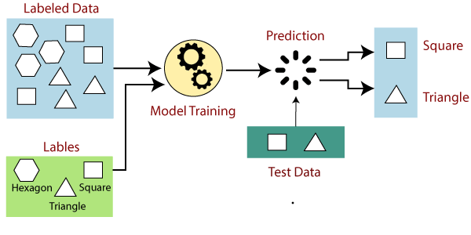

**Figure 2.7: Supervised machine learning classifying shapes (Javatpoint, 2021)**

* **Unsupervised learning**: Thisis where the input data is unlabeled and the system tries to learn structure from that data automatically, without any human guidance (Furbush, 2019). In supervised learning, the labels allow the algorithm to find the exact nature of the relationship between any two data points. However, unsupervised learning does not have labels to work off of, resulting in the creation of hidden structures. Relationships between data points are perceived by the algorithm in an abstract manner, with no input required from human beings (Anirudh, 2019). (Anirudh, 2019) furthermore explains use-cases that prompt the adoption of unsupervised machine learning over supervised learning by stating, instead of a defined and set problem statement, unsupervised learning algorithms can adapt to the data by dynamically changing hidden structures, this offers more post-deployment development than supervised learning algorithms. Anomaly detection, such as flagging unusual credit card transactions to prevent fraud, is an example of unsupervised learning.

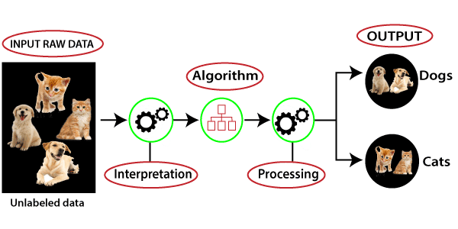

**Figure 2.8: Unsupervised machine learning classifying dog and cat (Javatpoint, 2021).**

* **Semi-supervised learning**: This is often a combination of the first two approaches. That is, the system trains on partially labeled input data—usually a lot of unlabeled data and a little bit of labeled data (Furbush, 2019). The systems that use this method are able to considerably improve learning accuracy. Usually, semi-supervised learning is chosen when the acquired labeled data requires skilled and relevant resources in order to train it / learn from it (Expert.ai, 2020). Facial recognition in photo services from Facebook and Google are real-world example and applications of this approach.

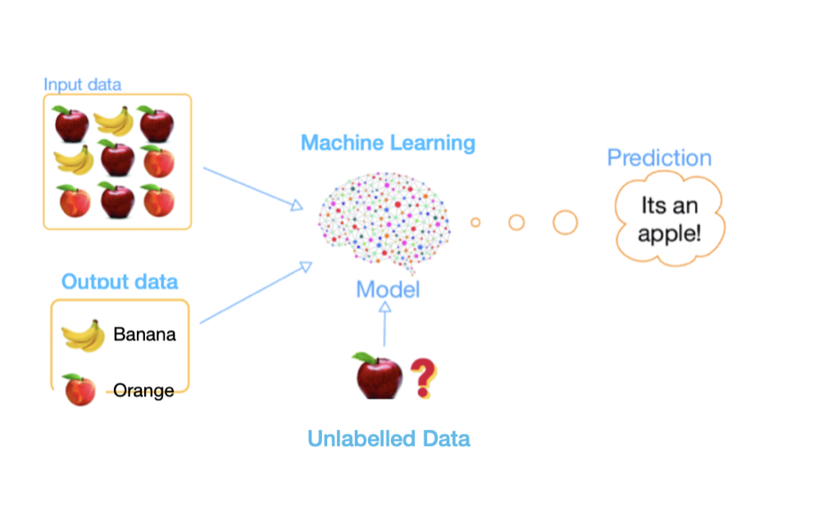

**Figure 2.9: Semi-supervised machine learning to classify the unlabeled apple (Kumar, 2017).**

* **Reinforcement learning**: This directly takes inspiration from how human beings learn from data in their lives, it features a system that improves upon itself and learns from new situations using a trial-and-error method (Anirudh, 2019). This is a learning method that interacts with its environment by producing actions and discovers errors or rewards (Expert.ai, 2020). In case of the program finding the correct solution, the interpreter reinforces the solution by providing a reward to the algorithm. If the outcome is not favourable, the algorithm is forced to reiterate until it finds a better result. In typical reinforcement learning use-cases, such as finding the shortest route between two points on a map, the solution is not an absolute value. Instead, it takes on a score of effectiveness, expressed in a percentage value. The higher this percentage value is, the more reward is given to the algorithm. Thus, the program is trained to give the best possible solution for the best possible reward (Anirudh, 2019).

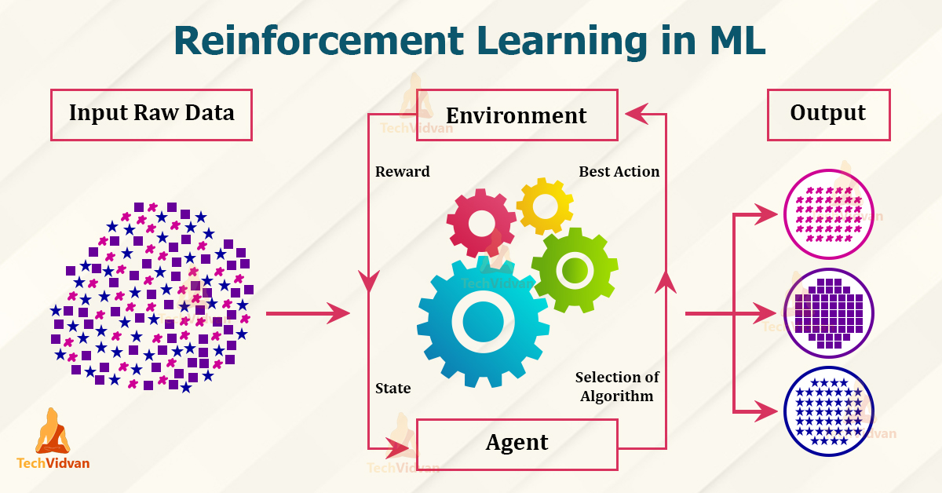

**Figure 2.10: Reinforcement machine learning process diagram (TechVidvan, 2021).**

* **Transfer learning**: Thisinvolves reusing a model that was trained while solving one problem and applying it to a different but related problem (Furbush, 2018). I found during research that this particular method is often not regarded by many researchers as it’s just gaining it momentum in the data science world, particularly machine learning, which I’ve found to as well be a core method of machine learning, hence why it’s included in this study. In transfer learning, the knowledge of an already trained machine learning model is applied to a different but related problem. For example, if you trained a simple classifier to predict whether an image contains a backpack, you could use the knowledge that the model gained during its training to recognize other objects like sunglasses. With transfer learning, it basically involves trying to exploit what has been learned in one task to improve generalization in another. We transfer the weights that a network has learned at "task A" to a new "task B". The general idea is to use the knowledge a model has learned from a task with a lot of available labelled training data in a new task that doesn't have much data (Donges, 2021). Lukas Biewald in the O'Reilly Artificial Intelligence Conference 2017 describes an example of transfer learning where a deep learning model was trained on millions of images of cats, then “fine-tuned” to detect melanoma in medical imaging.

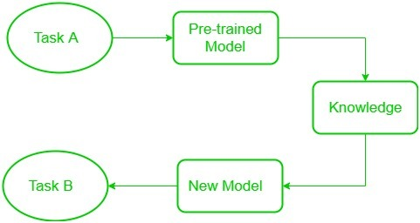

**Figure 2.11: Transfer machine learning process diagram (Chouhan, 2019).**

* 1. **Fake News Detection on Social Media**

According to studies, Researchers have provided a comprehensive survey about diverse aspects of false information and existing algorithms to detect false information available on the web (Srijan & Shah, 2018). The main objective of this research article is to describe all types of false information available on social media and existing algorithms to detect the same. In their work, a complete life cycle of fake news is deﬁned and future aspects comprehensively discussed. In the research from Zhou & Zafarani (2020), they explained and explored the fundamental theories across various disciplines to facilitate and enhance the interdisciplinary research of fake news. The authors have created multi-source datasets. These studies focus on fake news from four perspectives:

* 1. False knowledge, it carries
  2. Its writing styles
  3. Its propagation patterns
  4. The credibility of its creators and spreaders

Researchers investigated the differential diffusion of all of the verified true and false news stories distributed on Twitter from 2006 to 2017. The data they used comprises of 126,000 stories tweeted by 3 million people more than 4.5 million times. The researchers classified news as true or false using information from six independent fact-checking organizations that exhibited 95 to 98% agreement on the classifications. They also found that false news was more novel than true news, which they suggest that people were more likely to share novel information (Vosoughi, Roy & Aral. 2018). It was also reveal in the study that robots accelerated the spread of true and false news at the same rate, implying that false news spreads more than the truth because humans, not robots, are more likely to spread it. According to studies, researchers explored the effectiveness (accuracy) of their proposed hybrid framework for fake news classiﬁcation. The main objective of this research was to demonstrate a new way of assessing hybrid features from multiple news sources using different text categories of news. These categories are important to implement pre-screening for fake news detectors (Ruchansky, Seo, & Liu, 2017). In their research, the researchers used binary fake news dataset. Furthermore, in 2018 researchers proposed a model to recognize parody and content writing styles using in news articles, as previously discussed parody/satire as part of the types of fake news on social media, with the pictorial example on fig. 2.3. The researchers reviewed 360 satirical news articles specially focused on four areas, including civics, science, business, and ﬁnally stimulated news articles. They then proposed an SVM-based characterization in their investigation utilizing fundamentally ﬁve main features: Absurdity, Humor, Grammar, Negative Affect, and Punctuation. The authors achieved an accuracy of 38.8% with the proposed framework (Karimi, Roy, Saba-Sadiya & Tang, 2018). Some researchers have also described Tabloidization in the form of Click baiting, clickbaiting as discussed earlier as types of fake news on social with the pictorial example seen on fig. 2.1. The researchers described Clickbaiting as a form of rapid dissemination of rumour and misinformation online. The authors discussed potential methods for automatic detection of clickbait as a form of deception. Content cues which includes lexical and semantic level of analysis where implemented by the authors (Conroy, Rubin & Chen, 2016).

Facebook has faced an increasing criticism over its role in the 2016 US presidential election because it allowed the propagation of fake news disguised as news stories coming from unchecked websites. This spreading of false information during the election cycle was so severe that Facebook was labelled as “dust cloud of nonsense”. Thus, prompting them to review their post/news sharing on their service to create a system effective to combat fake news. Facebook and WhatsApp have been continuously working on fake news detection as they wrote in an article. The works have been continuously on for years now, with continuous improvements as well, and it is currently under the alpha phase according to (Verma & Bala, 2018). Facebook in an article quoted they are working to fight the spread of false news in two key areas. First is disrupting economic incentives because of most false news in financially motivated. Second one is Building new products to curb the spread of false news (Yimin, Rubin & Conroy, 2016). Some of the preventive measures taken by Facebook are:

* Ranking Improvements: News Feed ranks reduce the prevalence of false news content.
* Easier Reporting: Determine what is valuable and what is not. Stories that are flagged as false by our community than might show up lower in the user feed.

To stop the spread of misinformation, WhatsApp has as well implemented some security measures and also fake news detection, though these are under alpha phase and are not fully rolled out to the beta users. WhatsApp testing ‘**Suspicious Link Detection**’ feature: This feature will alert uses by putting a red label on links that it knows to lead to a fake or alternative website/news. Additionally, if a message has been forwarded from a device more than 25 times, the message could be blocked (Verma, 2018). Unlike most of the approaches used by the participating teams and authors described above, the solution proposed to tackle the fake news detection problem in this study is through using traditional machine learning techniques. Diﬀerent features and properties that could be used to distinguish fake news from real will be explored. By using those machine learning features, a combination of diﬀerent machine learning algorithms will be trained namely; Logistic Regression, Support Vector Machine and Random Forest algorithm. Upon which, each algorithm accuracy will be examined and compared to evaluate the best of each in detecting fake news on social media.

CHAPTER THREE

**METHODOLOGY**

1. **Introduction**

Methodology is a set of rules derived to interpret or solve different problems within the scope of a particular discipline. Machine learning usually requires a good amount of time for model training and testing, and also a huge and good quality of dataset

1. **Research Design**

A quantitative study is conducted to train and test various machine learning algorithm to determine the authenticity of news whether “fake” or “real”. Three machine learning algorithm was put to use, in order to get and select the best performing algorithm so as to maximize the news detection accuracy in detecting fake news on the social media.

1. **Research Tools and Materials**

The research is carried out with the use of the following:

* Kraggle.com for corpus news data
* Different social media news data
* Python programming language used to implement the models
* Sklearn (scikit-learn) used for the machine learning classifiers
* Numpy is a library function of python language used in this study for data computation
* Newspaper3k tool for cleaning datasets
* Pandas is a library function of python language and used in this study for data manipulation and analysis
* Beautiful soup used for web scrapping.

1. **Dataset**

Most of the efforts to detect fake news are limited by the data used. Ideally, to implement all features a dataset that contains news story labeled by specialists, their textual content, information about their sources, particularly in social media system would be needed as indicated in the project. Categorizing a news statement as “fake news” could be a very challenging and time-consuming task. For this reason, the use of an existing dataset, that has already collected and classified, has been made used. A recently created dataset is used

The sample size of this study is made up two separate datasets, both obtained from kraggle.com, in which each represent fake news from different news platforms online and real news from different platforms as well. The sample size is made up of 20000+ records from the corpus data gotten for the training for the system and as well the testing of the system.

1. **Dataset Collection**

**Phase 1: Data Construction**

Database site (**Kaggle.com**) was visited with the aim of getting adequate needed dataset for news posts on social media. Kaggle is an online repository for various datasets, it is the world's largest data science community with powerful tools and resources to help achieve data science goals (kaggle.com, 2021). Kaggle offers range of dataset according to need, the needed dataset for this study was labeled dataset due to the adoption of supervised machine learning algorithm for the data classification in this study. The dataset obtained from Kaggle was titled “**Fake and real news dataset**” matching the exact type of dataset needed for the system. All the data collected to be used for the credibility and accuracy as the evaluation metrics.

**Phase 2: Cleaning and Extraction**

Kaggle itself has its own dataset which is being crawled and cleaned by other researchers, unlike raw data scrapping from Twitter and Facebook. Dataset crawled online is cleaned by using Newspaper3k tool. Newspaper3k is a Python library that can scrape and clean the articles downloaded from the online sources. Then describe the dataset used in this work as well a simple implementation details for a large set of features for the fake news detection. The dataset unwanted variables such as authors, date posted, URL, and category are ﬁltered out. Articles with no body text in the article body are also removed. Multicolumn articles are transformed into single column articles for uniformity of format. These operations are performed on all the datasets to achieve consistency of format and structure.

2. **Training and Testing**

Training of the system in any machine learning procedure is one of the most paramount stages in machine learning. This is really important because the training is what helps derive at the intended goal of the system. With **supervised learning** used in this study, one is required to sort the dataset by choosing the data features to be used for the models. Training data to train the system were all labeled - that is, annotated so as to teach the machine how to recognize the outcomes of the fake news model it’s designed to detect. As there is no one algorithm suited for all tasks, different classifiers is used in this study to achieve the task.

1. **Logistic Regression Classifier**: Logistic Regression is one of the most commonly used Machine Learning algorithms for two-class classification as is the case in this project. It is easy to implement and can be used as the baseline for any binary classification problem. Logistic regression describes and estimates the relationship between one dependent binary variable and independent variable (Navlani, 2019)*.* It predicts the output of a categorical dependent variable. Therefore the outcome must be a categorical or discrete value. It can be either Yes or No, 0 or 1, true or False, etc. but instead of giving the exact value as 0 and 1, it gives the probabilistic values which lie between 0 and 1.
2. **Support Vector Machine**: It is known to easily handle multiple continuous and categorical variables. SVM constructs a hyperplane in multidimensional space to separate different classes. A hyperplane is a decision plane which separates between a set of objects having different class memberships (Navlani, 2018). The SVM is used to select a hyperplane with the maximum possible margin between support vectors in the given dataset, after which SVM searches for the maximum marginal hyperplane.
3. **Random Forest Classifier**: A random forest algorithm consists of many decision trees. The ‘forest’ generated by the random forest algorithm is trained through bagging or bootstrap aggregating. Bagging is an ensemble meta-algorithm that improves the accuracy of machine learning algorithms (section.io, 2020). Classification in random forests is employed as an ensemble methodology in this study to attain the outcome. The training data is fed to train various decision trees.

A combined corpus of two separate datasets is to be made use of, both obtained from kaggle.com, each comprising of already cleaned and determined fake news and opposite real news. 70% of the corpus data is used for training of the system and the remaining 30% to test the system out. Out of the three machine learning algorithm used, the best performing algorithm is then selected as the model to classify user input. Here, the preprocessing phase refers to the various stage of manipulation process, natural language processing techniques and feature selection, the best performing model is determined primarily via it accuracy, F1 scores as well as other metrics.

**CHAPTER FOUR**

**DATA ANALYSIS AND RESULT PRESENTATION**

* 1. **Introduction**

This chapter focuses on the analysis of data and the presentation of experimental result, accuracy, and descriptive analysis of all models in line with the objectives of the study.

* 1. **Descriptive Analysis of Dataset**

In this system, a machine learning model was trained to detect if a news is real or fake. The model uses “**Fake and real news dataset**” which has 23,503 fake news and 21,417 real news, making it a perfectly balanced dataset, along with 4 columns(title, text, subject and date) upon which a class is then inserted to classify the fake news to “0”, and the real news to “1” as well. The last 100 rows of both real news and fake news were removed for manual testing later on to manually test the system. After which the dataset was pre-processed to a dataset with two columns (text, class). A function is created to convert the text to lowercase, remove extra spaces, special characters, URL and links from the texts. This new dataset was divided into x and y variable where x variable holds both fake and real news and y variable holding the news classes. The variable x and y were further divided into x_train, x_test, y_train and y_test, the training set and testing set upon which 30% of the dataset is allocated for the testing set.The x variable was then fit transformed using CountVectorizer class which was gotten from feature extraction. This x_train and y_train where fitted and trained using three machine algorithms which are Random Forest Classifier, Logistic Regression, and Support Vector Machine.

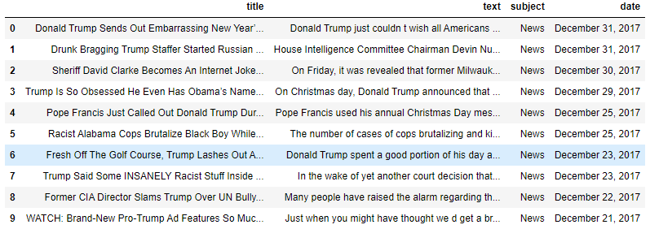

**Fig 4.1: showing original fake news dataset downloaded from kaggle.com**

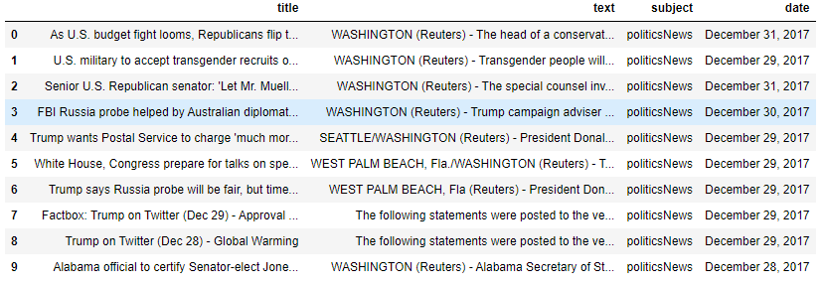

**Fig 4.2: showing original real news dataset downloaded from kaggle.com**

Figure 4.1 and 4.2 shows fake and real news dataset respectively as gotten from kaggle.com in line with data requirement for the system, a dataset comprising of 44,920 news data, both fake and real news, due the limited capability of the laptop device used in for the processing and running of this system, only 24,898 news data were made use of during the development of this system, as excess of this required a handful of time to process.

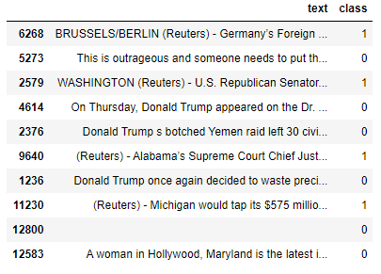

**Fig 4.3: showing news dataset after dropping unneeded columns**

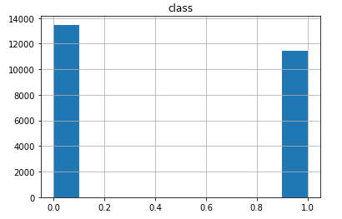

**Fig 4.4: showing a histogram of real and fake news**

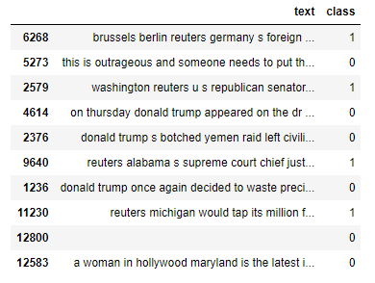

**Fig 4.5: showing news dataset after preprocessing**

From the figure 4.3, we can see the dataset after dropping the unneeded columns, as only the “text” column showing the full text of news data and “class” column showing the class (or dependant variable) of the news is required for the system. Preprocessing was performed on the dataset to clean the data, through the process of converting all text to lowercase, removing extra spaces, special characters, URLs, links and unneeded texts as seen in figure 4.5.

* + 1. **Count Plot of Dataset**

The countplot was used to represent the occurrence (counts) of the observation present in the categorical variable of dataset.

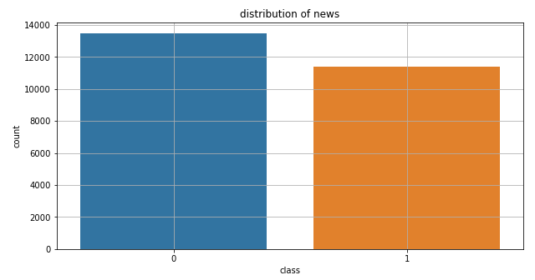

**Fig 4.6: showing count plot of dataset**

The figure above shows the counts of observations in each of the fake and real news using seaborn.countplot() method.

* + 1. **Check For Null Values In The Dataset**

Null or missing values are often somewhat troublesome when analysing data and creating machine learning models, as they often affect the integrity of the dataset. With that being the case, null values were examined in the system, this helps to figure out how perfect the dataset is, a dataset without null values indicates the dataset is good to use and work with.

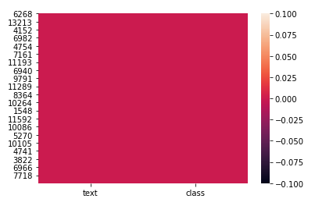

**Fig 4.7: showing null values in dataset**

The figure above shows that there are no missing values in the dataset, as it is indicated by the colour (red). Missing values are often needed to be identified when cleaning up data, analysing it, or before building a machine learning model. Missing values affect the performance and predictive capacity of the system. They have the potential to change all our statistical parameters and as thus, conclusions and analysis can be misleading. In the absence of missing values, the dataset is good and algorithm training and testing can proceed.

* + 1. **Training and Testing Data**

The dataset is split into two dataset, training data and testing data. The training data is used to builds up the machine learning algorithm; the model evaluates the data repeatedly to learn more about the data’s behaviour and then adjusts itself to serve its intended purpose of detecting the fake news and real news. As for the testing data, after the model is built, testing data once again validates that it can make accurate predictions on unseen news data, to confirm that the ML algorithm was trained effectively. The training set is expected to be large enough to yield statistically meaningful results, as a result the dataset was split into 70% training set and 30% testing set.

1. 1. **Experimental Result Analysis and Comparisons of Algorithms**

The efficiency of this system can be measured from its accuracy level. The performance of a classifier may vary based on the size and quality of the text data (or corpus) and also the features of the text vectors. Aside accuracy levels, other metrics examined were used in the analysis of each algorithm performance.

* 1. **Result Analysis**

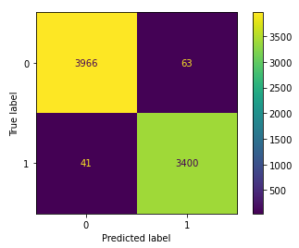

**Fig 4.8: showing confusion matrix of random forest classifier**

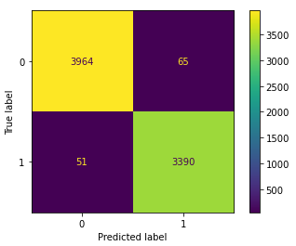

**Fig 4.9: showing confusion matrix of logistic regression classifier**

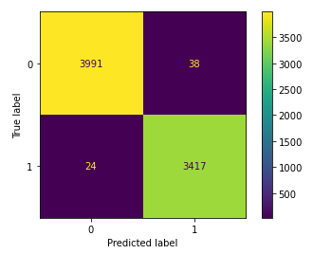

**Fig 4.10: showing confusion matrix of Support vector machine**

To evaluate the performance of algorithms, different metrics were used. Most of them are based on the confusion matrix. Confusion matrix is a tabular representation of a classification model performance on the test set, which consists of four parameters: true positive, false positive, true negative, and false negative. True Positive (TP) is the actual positive class that is correctly predicted as positive. True Negative (TN) is the actual negative class is correctly predicted as negative, while, False Positive (FP) is actual class that is negative but was wrongly predicted as Positive and lastly, False Negative (FN) is actual class is positive but wrongly predicted as negative. From figure 4.8, 4.9 and 4.10, we can calculate accuracy for the algorithms by adding true positive and true negative and then dividing by the total number of data. Accuracy is the simplest and mostly used measure to evaluate a classifier. It is defined as the degree of right predictions of a model.

Accuracy =

True positive + True negative

True positive + True negative + False positive + False negative

The 3 algorithms were tested and scored based on accuracy, Random Forest Classifier had an accuracy of about 98.6% Logistic Regression had an accuracy of about 98.4%, and Support Vector Classifier slightly outperforming other algorithms had an accuracy of about 99.1%. All algorithms produced a very high accuracy in the evaluation. In most cases, high accuracy value represents a good model, but considering the fact that we are training a classification model in our case, a news article that was predicted as true while it was actually false (false positive) can have negative consequences; similarly, if an article was predicted as false while it contained real news, this can create trust issues. Therefore, other metrics that take into account the incorrectly classified observation were made used of, which are precision, recall, and F1-score.

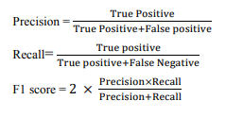

The respective precision, recall and f1 scores were calculated using the formula illustration above, Now, looking at the precision from figure 4.8, there are 3400 news which were predicted as real and are actually real which is the true positive and the total number of prediction of real is 3463. Therefore dividing 3400 by 3463 and then multiplying it with 100, we get a precision of 98.18% for the random forest classifier. In the same way from figure 4.9 and 4.10, precision for Logistic Regression is 98.11% and SVM having the best performing rate of 98.90%. Comparing the precision rate of the three algorithms, it is clear all the algorithms performs well, but SVM still slightly shows better rate in predicting the number of news articles that are true out of all the positively predicted (true) articles. This result indicates all the models performed well in rightly detecting the real news among all the predicted real news in the test. Moving on to the recall, from figure 4.8, there are 3400 news which were predicted as real and are actually real which is the true positive and total number of actual real news is 3441. Therefore dividing 3400 by 3441 and then multiplying it with 100, we get a recall of 98.81% approximately for the random forest classifier. Similarly, from figure 4.9 and 4.10, recall for Logistic Regression is 98.52% approximately and SVM again having the best performing rate of 99.30%. For the F1-score, F1-score represents the trade-off between precision and recall. Thus, it takes both the false positive and the false negative observations into account. F1-score for Random forest classifier was calculated to be 98.5% approximately, for the Logistic regression 98.3% approximately and for the SVM a F1-score of 99.1% slightly outperforming other metrics. The result of all these evaluation strongly indicate the efficiency and reliability of machine learning in detecting fake news on the internet, in essence, achieving the intended objective of the system.

Further evaluation metrics were carried out in order to get the best and all-round understanding of the model, metrics which include the sensitivity, specificity and null accuracy. Sensitivity can be explained as the prediction accuracy of the algorithm when the value is positive ( i.e. when the news is true, how often is the prediction correct), sensitivity is also known as True Positive Rate or Recall, as it carries same value as all the recall values stated earlier. Specificity is somewhat the opposite of sensitivity, it can be referred to as the prediction accuracy of the algorithm when the value is negative (i.e. when the news is fake, how often is the prediction correct). The specificity score for Random forest classifier is 98.43%, while Logistic regression achieved a score of 98.38% and lastly SVM achieved the best of 99.05%. The result gotten from the sensitivity and specificity metrics encompasses the credibility of the system, as it performs well in particularly predicting fake news and real news with high accuracy.

To ensure the system developed isn’t just a dummy system, the null accuracy was calculated and examined, Null accuracy is the accuracy that could be achieved by always predicting the most frequent class. To calculate this, we must examine the class distribution of the testing set, by calculate the percentage of fake and real news in the training set, with fake news in the set having 53.94% approximately and real news with 46.06% approximately as well. This means that a dumb model that always predicts 0 (fake class) would be right 54% of the time, which is way below the accuracy score of all models examined. This shows the classification accuracy is satisfactory as it's far from being a dumb model.

* 1. **Comparisons of Algorithms**

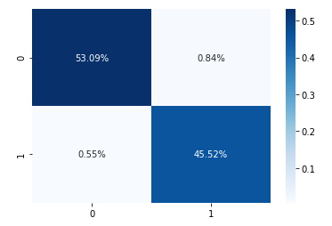

**Fig 4.11: showing confusion matrix result of Random forest in percentage**

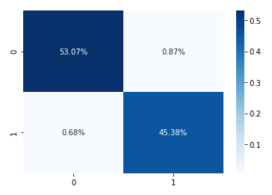

**Fig 4.12: showing confusion matrix result of Logistic regression in percentage**

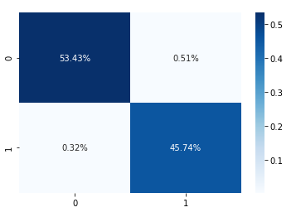

**Fig 4.13: showing confusion matrix result of Support Vector Machine in percentage**

From all the figures comparison from figure 4.8 to 4.10, as well as figure 4.11 to 4.13 and all the results analysis stated, it is evident that this models and all three algorithms examined performed brilliantly, but comparing result it is observable that that the Support Vector Machine slightly has the best performance on the dataset in the model, with SVM having a slightly better result in all metrics than the other classifiers, from the algorithm accuracy, to the precision, recall and F1-score. The same can be perceived from the sensitivity and specificity rate, with the SVM achieving an outstanding 99.3% and 99.0% respectively. Indicating the model is highly sensitive and highly specific meaning the algorithms performs well in predicting actual real news to be real with fewer errors and also performs well in predicting actual fake news to be fake with less error as well. Logistic regression performed the least among all model but performed satisfactorily regardless, with it achieving a accuracy of 98.4%, while Random Forest edged out with 98.6%, and Support vector Machine with the best of all of 99.1%. Logistic Regression also performed just a fraction below Random Forest in it precision, recall and f1-score, with a score of 98.1%, 98.5%, and 98.3% respectively and Random Forest achieving 98.2%, 98.8%, and 98.5% in its evaluation and SVM outperforming all others with 98.9%, 99.3%, and 99.1% in its evaluation result. Comparing all these metric scores and taking them into consideration, the Random Forest can be rated to be the second best performing algorithm in prediction fake and real news below Support Vector Machine which performed best and slightly edging out the Logistic Regression classifier.

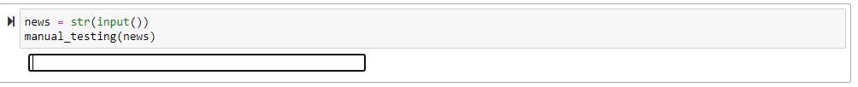

**Fig 4.14: showing manual entry input space for model testing**

An additional manual entry for continuous prediction of news was added to the system upon which, news articles from news websites can be copied and pasted in the news entry space, upon which the news will be processed and the system prediction will be displayed for the result. This helps to add more value to the system as further news can be tested for the accuracy using the system, this is illustrated in figure 4.14 and 4.15.

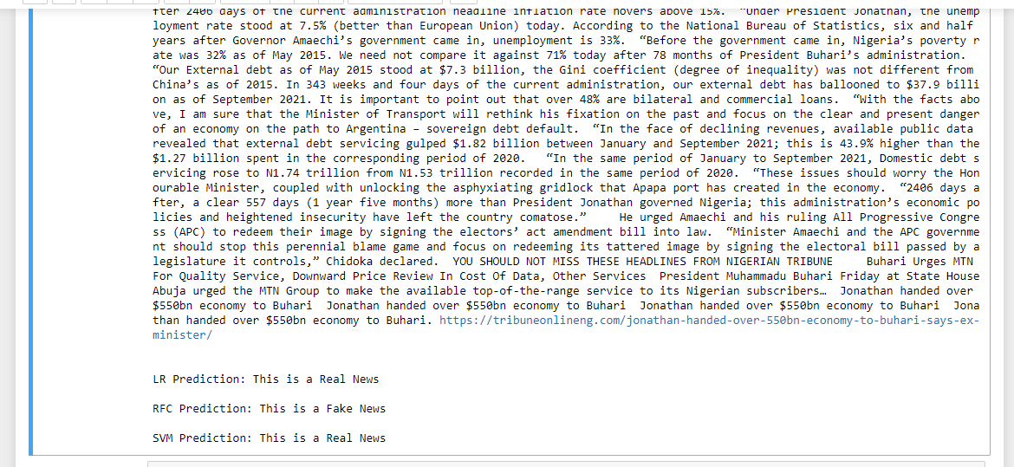

**Fig 4.15: showing manual entry news data and model prediction result**

**CHAPTER FIVE**

**SUMMARY, CONCLUSION AND RECOMMENDATIONS**

* 1. **INTRODUCTION**

Discussion of the findings made, conclusion and necessary recommendations for further studies, are discussed in this chapter.

* 1. **SUMMARY**

In this study, a machine learning model was trained to detect fake news and classify fake news articles on different social media news websites. This system uses supervised machine learning, with three different machine learning algorithms used. A “Fake and real news” dataset was obtained from an online free dataset repository website, the dataset comprised of different news data which was used in training the system and as well a percentage of it used it testing the system. Upon which different machine learning evaluation metrics were carried out to examine and analyse the performance of all algorithms implemented in the system. Some algorithm achieved comparatively higher accuracy than others. Multiple performance metrics were used to get optimum understanding and analysis of each algorithm performance. The Support Vector Machine classifier (SVM) showed an overall better score on all performance metrics as compared to the other two algorithms in comparison in predicting the news data.

* 1. **CONCLUSION**

The fake news challenge is troubling issue and is spreading rapidly like a wildfire as it becomes easier for information to reach the mass in various flavours, the internet has provided a low-cost distribution channel for fake news as many news articles online don’t go through any check before being posted online. With the help of machine learning, we can control and limit the spread of such misinformation more quickly and efficiently as compared to manual efforts and with a high accuracy performance of the machine learning models in this study, it use and performance demonstrates its high suitability and reliability for solving a classification problem of fake news in real life scenarios. Machine learning is a clear beneficial approach to tackling the widespread issue of fake news on social media and internet as a whole.

Machine learning also brings effectiveness as observed in this study as it is enables the luxury of accomplishing tasks smarter, faster and better. Machine learning offers flexibility as machine learning can easily consume unlimited amounts of news data with timely analysis and assessment, and also particularly helps in automating the task of manually identifying fake news, thereby freeing up time for more productive use. The primary aim of the project is to develop a machine learning system that identify patterns in text that differentiate fake articles from true news, upon which can be concluded to have performed excellently in meeting the objective, with the Support Vector Machine superseding other evaluated algorithm in the classification. In comparison with various previous works, this study can be considered as a step forward toward building a complete social media based system for analysing and predicting news online.

* 1. **RECOMMENDATION**

Fake news detection on social media websites still has some issues that require further attention and deep research. An example would be, identifying key elements involved in the spread of news is an important step, in order to reduce the spread of fake news. As well, fake news identification in images and videos to be implemented in machine learning would be a significant possible future direction.

REFERENCES

Anirudh V.K. (2019, December). *What Is Machine Learning: Definition, Types, Applications and Examples.* https://www.toolbox.com/tech/artificial-intelligence/tech-101/what-is-machine-learning-definition-types-applications-and-examples/

Burkhardt, J.M. (2018). *History of Fake News.* https://journals.ala.org/index.php/ltr/article/view/6497/8631

Burns, E. (2021, March 30). *Machine learning*. Search Enterprises AI https://searchenterpriseai.techtarget.com/definition/machine-learning-ML#:%7E:text=Machine%20learning%20(ML)%20is%20a,to%20predict%20new%20output%20values.

Chouhan, V. (2019). *Introduction to Transfer Learning* [Figure 2.11]. GeeksforGeeks. https://www.geeksforgeeks.org/ml-introduction-to-transfer-learning/

Collins Dictionary (2017). Word of the year 2017. *Collins English Dictionary*. https://www.collinsdictionary.com/woty

Conroy, N., Rubin, V & Chen, Y. (2015). *Automatic Deception Detection: Methods for Finding Fake News*. https://asistdl.onlinelibrary.wiley.com/doi/full/10.1002/pra2.2015.145052010082

Desai, S., Mooney, H., & Oehrli, J. A. (2021, July 22). *“Fake News,” Lies and Propaganda: How to Sort Fact from Fiction*. Research Guides. https://guides.lib.umich.edu/fakenews

Donges, N. (2021, August 12). *What Is Transfer Learning? Exploring the Popular Deep Learning Approach.* Built In. https://builtin.com/data-science/transfer-learning

Expert.ai Team, E. (2021, May 26). *What is the Definition of Machine Learning?* Expert.AI. https://www.expert.ai/blog/machine-learning-definition/

Faggella, D. (2020, February 26). *What is Machine Learning?* Emerj. https://emerj.com/ai-glossary-terms/what-is-machine-learning/

Furbush, J. (2018, May 3). *Machine learning: A quick and simple definition*. O’Reilly Media. https://www.oreilly.com/content/machine-learning-a-quick-and-simple-definition/

Gulli A. & Pal S. (2017). *Deep Learning with Keras*. https://www.perlego.com/book/527043/deep-learning-with-keras-pdf

Hannah Ritchie. (2016, December 30). *Read all about it: The biggest fake news stories of 2016*. Special to CNBC.com. CNBC. https://www.cnbc.com/2016/12/30/read-all-about-it-the-biggest-fake-news-stories-of-2016.html

Higdon, N. (2020). *Anatomy of Fake News* (First ed.). University of California Press. https://www.perlego.com/book/1584627/the-anatomy-of-fake-news-a-critical-news-literacy-education-pdf

JavaTpoint. (2021). *Supervised Machine Learning* [Figure 2.7]. Javatpoint. https://www.javatpoint.com/supervised-machine-learning

JavaTpoint. (2021). *Unsupervised Machine Learning* [Figure 2.8]. Javatpoint. https://www.javatpoint.com/unsupervised-machine-learning

Kaggle. (2020, March 26). *Fake and real news dataset* [Dataset]. Kaggle Dataset. https://www.kaggle.com/clmentbisaillon/fake-and-real-news-dataset

Kaggle (2021). *Kaggle: Your Machine Learning and Data Science Community.* https://www.kaggle.com/

Kalsnes, B. (2018).  Fake News. *Oxford Research Encyclopedia of Communication.* https://oxfordre.com/communication/view/10.1093/acrefore/9780190228613.001.0001/acrefore-9780190228613-e-809

Karimi, H., Roy, P., Saba-Sadiya, S., & Tang, J. (2018*). Multi-Source Multi-Class Fake News Detection*. https://aclanthology.org/C18-1131/

Khaldarova, I., & Pantti, M. (2016). Fake News. *Journalism Practice*, *10*(7), 891–901. https://doi.org/10.1080/17512786.2016.1163237

Klein, D. O., & Wueller, J. R. (2018). Fake News: A legal perspective. Australasian Policing, 10(2). https://search.informit.org/doi/10.3316/informit.807638896756480

Kumar, R. (2017, May 27). *Semi-Supervised Learning* [Figure 2.9]. Medium. https://medium.com/enjoy-algorithm/supervised-unsupervised-and-semi-supervised-learning-64ee79b17d10

Navlani, A. (2019)*. Understanding Logistic Regression in Python*. Data camp https://www.datacamp.com/community/tutorials/understanding-logistic-regression-python

Newman, N., Kalogeropoulos, A., Nielsen, R. K., & Fletcher, R. (2019). Reuters Institute Digital News Report 2019. *Reuters Institute for the Study of Journalism*. Published. https://reutersinstitute.politics.ox.ac.uk/our-research/digital-news-report-2019

Pérez-Rosas V., Kleinberg B., Lefevre A & Mihalcea R. (2019). *Automatic Detection of Fake News*. https://aclanthology.org/C18-1287.pdf

Pickard, V. (2016). Media Failures in the Age of Trump. *The Political Economy of Communication,* *4* (2), 118-122. https://repository.upenn.edu/asc_papers/753

Ruchansky, N., Seo, S., & Liu, Y. (2017). CSI. *Proceedings of the 2017 ACM on Conference on Information and Knowledge Management*. CSI Published. https://doi.org/10.1145/3132847.3132877

Schade, U. (2019). *Software that can automatically detect fake news*. Fraunofer. https://www.fraunhofer.de/en/press/research-news/2019/february/software-that-can-automatically-detect-fake-news.html

Section.io (2020, December 11). *Introduction to Random Forest in Machine Learning*. Section.Io. https://www.section.io/engineering-education/introduction-to-random-forest-in-machine-learning/#:~:text=A%20random%20forest%20is%20a%20machine%20learning%20technique%20that's%20used,consists%20of%20many%20decision%20trees.

Srijan, K. & Shah, N. (2018, April 23). *False Information on Web and Social Media.* A Survey. ArXiv.Org. https://arxiv.org/abs/1804.08559

Stein-Smith, K. (2017). *Librarians, information literacy, and fake news*. Strategic Library, 37(1-4). http://www.libraryspot.net/SL/SL_Mar17_1.pdf

TechVidvan. (2021). *Reinforcement Learning Algorithms and Applications* [Figure 2.10]. TechVidvan. https://techvidvan.com/tutorials/reinforcement-learning/

Verma, D., & Bala, M. (2018, October 1). *A Critical Review of Digital Marketing*. Papers. https://papers.ssrn.com/sol3/papers.cfm?abstract_id=3545505

Vosoughi, S., Roy, D., Aral, S. (2018). *The spread of true and false news online. Science* 359(6380), 1146–1151. https://doi.org/10.1126/science.aap9559

Wardle, Derakhshan. (2017). INFORMATION DISORDER*: Toward an Interdisciplinary Framework for Research and Policy Making*. Published. https://www.researchgate.net/publication/339031969_INFORMATION_DISORDER_Toward_an_interdisciplinary_framework_for_research_and_policy_making_Information_Disorder_Toward_an_interdisciplinary_framework_for_research_and_policymaking

Webwise. (2021). Explained: *What is False Information (Fake News)?* https://www.webwise.ie/teachers/what-is-fake-news/

Wikipedia contributors. (2021, August 29). *Fake news*. Wikipedia. https://en.wikipedia.org/wiki/Fake_news

Yimin, C., Rubin, V. L., & Conroy, N. K. (2015). Deception detection for news: Three types of fakes. *Proceedings of the Association for Information Science and Technology*, *52*(1), 1–4. https://doi.org/10.1002/pra2.2015.145052010083

Zhang, X., & Ghorbani, A. A. (2020). An overview of online fake news: Characterization, detection, and discussion. *Information Processing & Management*, *57*(2), 102025. https://doi.org/10.1016/j.ipm.2019.03.004

Zhou, X., & Zafarani, R. (2020). A Survey of Fake News. *ACM Computing Surveys*, *53*(5), 1–40. https://doi.org/10.1145/3395046